**PROJECT REPORT**

On

**“AUTOMATIC IRRIGATION SYSTEM”**

*Submitted in Full fulfillment of the requirements for The Eight Semester of the degree of*

**Bachelor of Engineering In**

**Mechanical Engineering**



**Visvesvaraya Technological University during the year 2019-20**

Carried out by

**NISHCHAL.K 1SB16ME054**

**NISHCHAY.K 1SB16EC029**

**NAVEEN.NB 1SB16ME051**

Under the guidance of

**PROF.BALAJI V**

Asst. Prof

Dept. of Mechanical Engg.

**SRI SAIRAM COLLEGE OF ENGINEERING**

**Sai Leo Nagar, Guddanahalli Post, Anekal Bangalore-562106**



**Department of Mechanical Engineering**

**CERTIFICATE**

Certified that the Project entitled **AUTOMATIC IRRIGATION SYSTEM** is a bonafide work carried out by **NISHCHAL.K (1SB16ME054), NISHCHAY.K (1SB16EC029), NAVEEN.NB (1SB16ME051),** in partial fulfillment for the award of Bachelor of Engineering in **Mechanical Engineering** of the Visvesvaraya Technological University, Belgaum during the year **2019-2020**. It is certified that all corrections/suggestions indicated for Internal Assessment have been incorporated in the Report deposited in the department library. The Project report has been approved as it satisfies the academic requirements in respect of Project work prescribed for the Bachelor of Engineering Degree.

|  |  |  |
| --- | --- | --- |
| Sign of the Guide | Sign of the HOD | Sign of Principal |
| Prof.BALAJIV | Prof.BALAJIV | Dr.B Shadaksharappa |

NISHCHAL.K 1SB16ME054

NISHCHAY.K 1SB16EC029

NAVEEN.NB 1SB16ME051

Name of the Examiners Signature with date

1……………………….. ………………….

2………………………. …..........................

**ACKNOWLEDGEMENT**

It has been an honor and privilege to do my Project report on **AUTOMATIC IRRIGATION SYSTEM.** I take this opportunity to convey my sincere thanks and regards to everyone who has helped me in successful completion of this project.

I take immense pleasure in expressing my sincere gratitude to **Dr.B SHADAKSHARAPPA, Principal of SSCE BENGALURU,** for giving me a constant encouragement and support to achieve my goal.

My sincere thanks to **Prof. BALAJI V, Head of Department, Mechanical Engineering** for permitting us to undertake the Project work and for his invaluable guidance.

I would like to thank my guide **PROF.BALAJI V, Dept. of Mechanical Engineering**. Without their constant motivation and guidance at every stage of this Project, this work could not have been materialized.

I express my deepest thanks to **PROF. CHARLES, Dept. of Mechanical Engineering** for taking part in useful decision and guidance and arranging all facilities. I choose this moment to acknowledge his contribution gratefully.

I perceive as this opportunity as a big milestone in my career development. I will strive to use gained skills and knowledge in the best possible way, and will continue to work on their improvement, in order to attain desired career objectives. Hope to continue cooperation with all of you in the future.

CONTENT

|  |  |  |
| --- | --- | --- |
| SLNO. | TITLE | PAGE  NO. |
| 1. | ABSTRACT | 1 |
| 2. | INTRODUCTION | 2 |
| 3. | PROPOSED SOLUTION | 3 |
| 4. | SPECIFICATION  4.1 Arduino Uno  4.2 SIM800A Quad Band GSM Module  4.3 L298N H-bridge Module  4.4 Soil Moisture sensor  4.5 Water level sensor  4.6 Voice Record Module - ISD1820  4.7 Raspberry pi 3b+ | 4-7 |
| 5. | Further Technological Implementations: | 8 |
| 6. | WORKING PRINCIPLE | 9-11 |
| 7. | LITERATURE SURVEY | 12 |
| 8. | METHODOLOGY | 13 |
| 9. | FINANCIAL IMPLICATION FOR THE VILLAGE: | 14 |
| 10. | IMPLEMENATATION AND OUTREACH PLANE | 15 |
| 11. | ADVANTAGES & DISADVANTAGES | 16 |
| 12. | CONCLUSION | 17 |

# ABSTRACT

Agriculture is the source of living of majority Indians and its also has a countless influence on economy of the country. The objective of over project is to reduced the man power or manual involvement by the farmer in the farming field by implementing automatic irrigation system. Were as this system has two different process in this operation were one operation and also been used in urban areas. This “AUTOMATIC IRRIGATION SYSTEM” Is to enhance water to crop and at the same to maintain water management by over irrigation and over flow of water from tank this operation is all controlled by arduino microcontroller and GSM module with water sensor and soil moisture sensor. The information to farmer is given through phone call. We used voice module to inform farmer about the farming field and Raspberry Pi to deduct weather the plants is good health .

# INTRODUCTION

As we know that Indian economy is one of the largest developing economies of the world. The agricultural sector has its largest contribution in the Indian economy. To achieve maximum utilization of man power and to obtain maximum profit in a given stipulated there is a need in the up gradation of various engineering techniques that are being used today. Thus maintaining proper amount of water level in the soil is one of the necessary requirements to harvest a good crop that can be a source of various types of nutrients whether micro or macro for their proper growth. If we talk about Indian farmers they are worst hit by the famines that occurs due to failure of crops depending upon various drought factors.

Rain plays the key role in deciding the future of these crops as well as the farmers every year. The over utilization of ground water has drastically reduced the ground water level in the last 15 years. So it is the need of hour to utilize each and every drop of water wisely so that it can also be used by our coming generations also. Also we should develop some new methods that use the renewable sources of energy. The developments of these new techniques are going to reach our goal of sustainable development as well as to cut off the emission of greenhouse gases to a minimum level. As the name of our project that is **“AUTOMATIC IRRIGATION SYSTEM”** with the help of the electricity power is a step to utilize some new engineering techniques. This technique will be a very good option for the small and medium farmers who suffer every year just because of failure of crops that took place every year that took place every year. The implementation of this technology has a wide scope in the nearby future.

# PROPOSED SOLUTION

An automatic irrigation system does the work quite efficiently and with a positive impact on the place where it is installed. Once it is installed in the agricultural field the water distribution to crops and nurseries becomes easy and doesn’t require any human support to perform the operations permanently This proposed solution allows flexible control of the values for releasing water to agricultural fields. It provides possibility for user to set up for irrigation where closing of the values can be scheduled based on sensing moisture contain in soil for irrigation and amount of water in the tank. It is an experimental scale within rural areas where there is an enormous is position of irrigation system which is executed using arm controller and wireless communication. The aim of this implementation was to demonstrate that the automatic irrigation system can be used to optimize /reduce water usage. It can also be a photovoltaic irrigation system which consists of a solar powered that is the soil moisture sensor and temperature sensor placed under the soil where plants roots are reached which is a distributed network. The system has a water level sensor which will indicate the presence of water level in tank. A software application was advanced by programming the verge values of soil moisture water level that was automated into a microcontroller. Were we also use voice module to inform farmer but overflow of water in farm are in water tank and take immediate action on it so that water is not wasted on empty land .we are also collecting data on some plants to make this project into more advance level (like image processing) through the help to “RASPBERRY Pi 3” used to deduct weather the plants is good health if not the it send farmer a message saying that problem in growth are disease to plants and send the perfect message to farmer on best medicines or self-medication give to plants . will this make farmer easy to take action will this process is going through so research and testing.

# SPECIFICATION

## Arduino Uno:

* Single-board microcontroller
* Microchip ATmega328P microcontroller

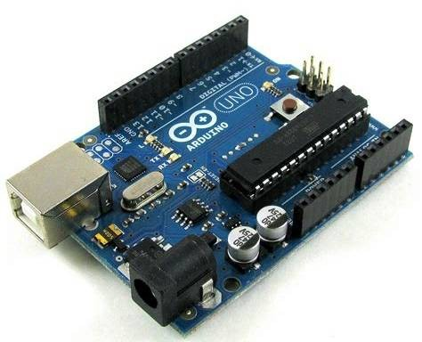It is the brain of the system, takes monitors the condition of soil, Water level in tank and also controls motor circuit.

## SIM800A Quad Band GSM Module:

* Bands: GSM 850MHz, EGSM 900MHz, DCS 1800MHz, PCS 1900MHz
* temperature: -40C to +85C
* One SIM card interface

Connected to Microcontroller it will dial the number i.e. stored mobile number (farmer’s).

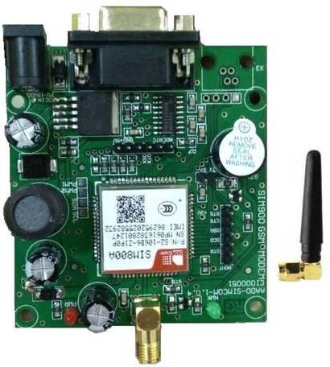

## L298N H-bridge Module:

* + 5V DC to 35V DC
  + onboard 5V regulator
  + Two submersible motors of 12V are driven by this module
  + Controls
* Sump to farm pump
* Water source to storage sump pump

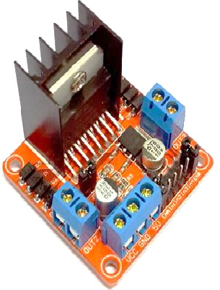

## Soil Moisture sensor:

* + senses moisture level in water
  + When it is below threshold value it triggers Arduino

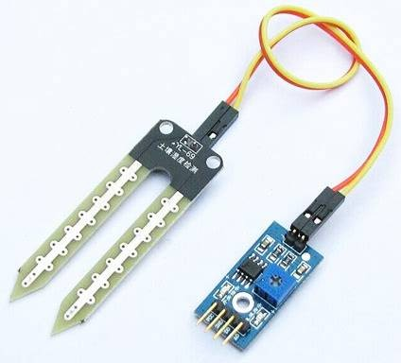

## Water level sensor:

* + senses water level in the storage sump
  + Gives reading to the Arduino about the water level

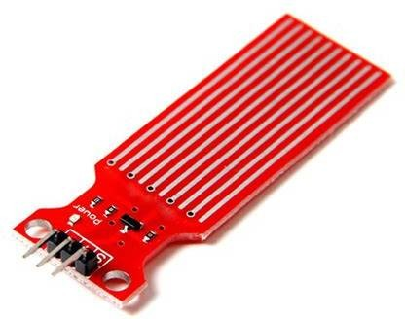

## Advantages of this system:

* + Farmer need not to be in field to irrigate plants
  + Arduino monitors the field
  + Two dedicated motors supply water to the field
  + Calling feature helps farmer to know his field conditions It directs water to field or sump based on conditions

**Voice Record Module - ISD1820**

Voice Record Module is base on ISD1820, which a multiple message record/playback device. It can offers true single chip voice recording, no-volatile storage, and playback capability for 8 to20 seconds. If you want change record duration, an external resistor is necessary to select the record duration and sampling frequency, which can range from 8 - 20 seconds (4-12kHz sampling frequency). The Voice Record Module of our provide default connect 100k resistor through P2 by short cap. So the default record duration is 10s.

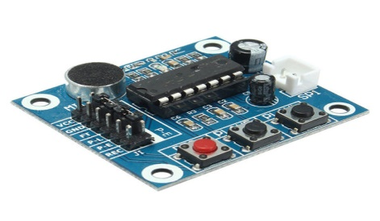

**Raspberry pi 3b+:**

* Some people have bought many RPi’s to make a super computer cluster. It’s difficult to do, but an option if you want a more powerful computer. You do have to buy everything else (monitor, keyboard, mouse etc. However you can use existing TV monitor and existing IO devices)
* It’s SMALL. Fits in the palm of your hand. In your pocket. The Raspberry Pi Zero is even smaller. Less than half of a playing card. Great for putting in small spaces.
* It has GPIO pins. So it can interface with real world devices, electronics, relay units, water pumps, sensors etc.
* Highly CUSTOMISABLE. You can add whatever sensors, cameras, batteries, touch screens, fans, electronics, robotics, remote control devices to it. Thus you can use it to solve many real problems like an automated water system to keep your plants alive while you’re on holidays.
* ENERGY EFFICIENT. Uses very little electricity. (1.21W). So you can use this to run a 24/7 home server without sucking too much electricity.
* 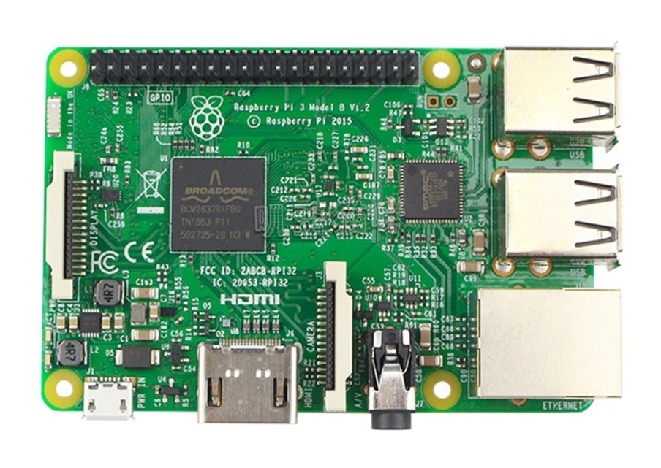You can run other OS’s like Retro-Pi which is essentially a NES, SNES and other retro console emulators, which you can put in a case, connect a controller and use as dedicated retro gaming console.

**Further Technological Implementations:**

* + - Internet of Things using cloud knowing temperature and humidity supply of water to crop
    - Voice messaging and recognition Information through voice call
    - Real time image processing identifying plant /crop condition and informing to farmer

**Automatic irrigation system**

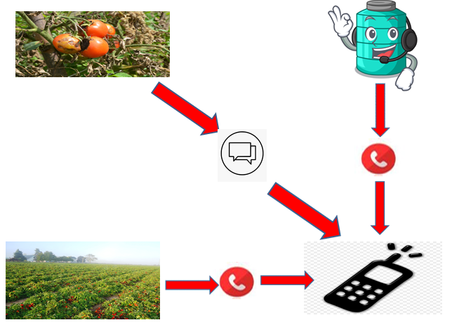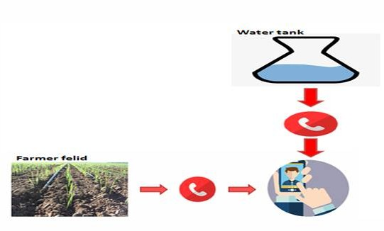

**Automatic irrigation system 2.0**

# WORKING PRINCIPLE

The main working principle behind this system is in connecting the soil moisture sensor, which was previously embedded into the plant, to the Arduino microcontroller, which is also connected to other electronic components listed above as shown in Figure . Measurement of soil moisture is done by the sensor which forwards the infor- mation and parameters regarding the soil moisture to the microcontroller, which controls the pump. If the level of soil moisture drops below a certain value, the microcon- troller sends the signal to the GSM module which then runs a pump and certain amount of water is delivered to the plant and water tank. Once the enough water is delivered, the pump stops doing its work. Power supply has a task to power the complete system and the recommended voltage should re- spect the input supply range for the microcontroller, that is, from 7V to 12V. GSM module is a simple circuit con- sisting of a single transistor, several resistors, diodes and a relay and it is controlled digitally by microcontroller. Since the complete system should be embedded in a small box, Arduino UNO is a perfect microcontroller for this purpose because of its dimensions and its work perfor- mance. Soil moisture module is consisting of the two parts: amplifier circuit and probes. This module has digital and analog outputs, where digital output is set to logical 1 when the threshold is activated. The threshold is set by potentiometer. Analog output gives the real time informa- tion regarding the moisture in the plant and this output is used in the system. Water pump is connected to the H-Bridge and it only works when the GSM module gets a command from the microcontroller, whose working prin- ciple is described via flow chart diagram in Figure 2 below as well as by the following pseudocode. Were we also use voice module to inform farmer but overflow of water in farm are in water tank and take immediate action on it so that water is not wasted on empty land .we are also collecting data on some plants to make this project into more advance level (like image processing) through the help to “RASPBERRY Pi 3” used to deduct weather the plants is good health if not the it send farmer a message saying that problem in growth are disease to plants and send the perfect message to farmer on best medicines or self-medication give to plants . will this make farmer easy to take action will this process is going through so research and testing

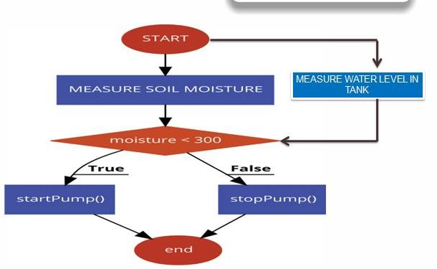

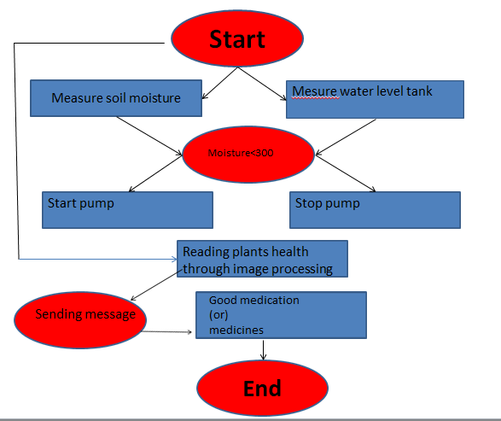

Automatic irrigation system 2.0

# LITERATURE SURVEY

**Paper title** : International journal of trend in scientific research and development (ISSN : 2456-6470)

**Journal title** : Automatic plant irrigation system.

**Author** : Md . Sajid Abbas

**Year of** 2017

**publication**

**Work done** : The main working principle behind the system is in connecting the soil

moisture sensor which was previously embedded into the plant .Measurement of soil moisture is done by the sensor which forwards the information and parameters regarding the soil moisture to the microcontroller which controls the pump if the water level in soil is less.

**Result** :The overall representation of our tested automatic plant irrigation system based on arduino microcontroller and sensor technology

**Conclusion** :It seems to be more demanding and challenging there are many other possibilities like creating complex connection plants of similar variety or so- called “Internet of plants” also using more than one sensor is another idea for an experimental venture .

# METHODOLOGY

The automatic irrigation system was designed to continuously sense the moisture level of the soil. The system responds appropriately by watering the soil with the exact required amount of water and then shuts down the water supply when the required level of soil moisture is achieved. The reference level of soil moisture content was made to be adjustable for the three most common soil samples (sandy, loamy and clayey soils – the samples used for this project were taken from around the Covenant University EIE building, Nigeria). Also the amount of irrigation, The moisture sensors were designed using probes made from corrosion-resistant material which can be stuck into soil sample. Voltage levels corresponding to the wet and dry states of the soil sample were computed by measuring the resistance between the moisture detector probes and matching them to output voltages of a comparator circuit. A submersible low-noise micro water pump was developed to deliver the water to the appropriate parts of the soil (the base of the plants). The volume of water required for irrigation per time was computed by considering the capacity of the water pump and the water channels. The required irrigation time was determined by considering the response time of the water pump and the water volume required per irrigation instance. A timing circuit was designed to use the required irrigation time to control the duration of each irrigation instance. Simulations were done using Proteus™ circuit simulation software. Circuit construction was done on a Vero board. I.e. the volume of water delivered to the soil, will be adjustable by the system operator (mild, nominal and high levels). The block diagram of the system developed is shown in figure

Were we also use voice module to inform farmer but overflow of water in farm are in water tank and take immediate action on it so that water is not wasted on empty land .we are also collecting data on some plants to make this project into more advance level (like image processing) through the help to “RASPBERRY Pi 3” used to deduct weather the plants is good health if not the it send farmer a message saying that problem in growth are disease to plants and send the perfect message to farmer on best medicines or self-medication give to plants . will this make farmer easy to take action will this process is going through so research and testing

# FINANCIAL IMPLICATION FOR THE VILLAGE:

The automatic irrigation system helps the farmer and the world by water management and save water. farmer can work on some other work in field to increase his income while the irrigation will been doing its works in field by informing farmer through call. To implement it in flied in cheaper price ways were farmer can afford it and we teach them provide all the connection after implementing this farmer need not to worry about water problem in farming field





Will after implementation of automatic irrigation system the need not to been present in farmering felid mean while farmer and concentrate on some business to grow is capital gain . this is the best choose for gowring income for farmer . presence of farmer can been anytime to field he to check out this is only the involvement required by farmer.

**IMPLEMENATATION AND OUTREACH PLANE:-**

* This project we created this mainly for farming field and there is one part of the project which can also been used in urban area.
* By doing some research and by asking farmer about their problem face and by seeing the water pollution and wastage of water in world with lack of water management.
* In farming field by over irrigation and over flow of water tank farmer cannot be present in 2 situations at a same time so automatic irrigation process is implemented to farmer felid.
* we personal ask farmer to take over product and test it and collected some feedback what are the problem faced and run over through and again implementation this to over main field is under process

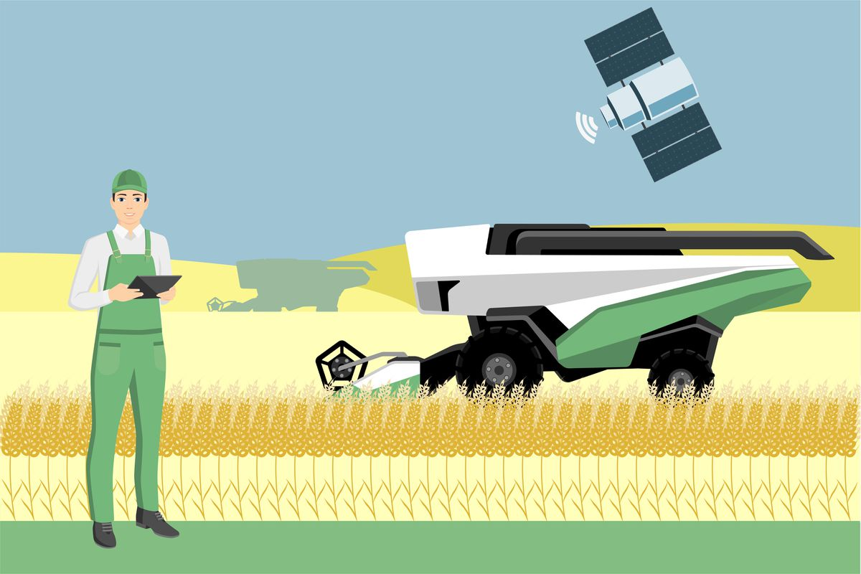

**ADVANTAGES & DISADVANTAGES:**

**Advantages:-**

* Automation elimination the manual operation of opening or closing valves
* Possibility to change frequency of irrigation and fertigation processes and to optimize these processes
* Adoption od advanced crop system and new technologies, especially new crop system that are complex and difficult to operate manually
* Use of water from different source and incersed efficeiency in water and fertilisesr use
* System can be operated at night water loss from evaporation is thus minimized
* Irrigation process start and stops exactly when required thus optmising energy requriments.

**DISADVANTAGES:-**

* The system can be very expensive it only takes one time investment .
* Self-help compatibility is very low with big scale system, which are very complex.
* Most automated irrigation system system

# CONCLUSION

Thus the “Automated Irrigation system based on soil moisture” has been designed and tested successfully. It has been developed by integrated features of all the hardware components used. Presence of every module has been reasoned out and placed carefully, thus contributing to the best working of the unit the moisture sensors measure the moisture level (water content) of the different plants. If the moisture level is goes to be below the desired and limited level, the moisture sensor sends the signal to the Arduino board which triggers the Water Pump to turn ON and supply the water to respective plant using the Rotating Platform/Sprinkler. When the desired moisture level is reached, the system halts on its own and the water Pump is turned OFF. Thus, the functionality of the entire system has been tested thoroughly and it is said to function successfully. Further more technology is going to implemented in this this project .will I personal implementing this in my small farm house